Reg No. - IT24100871

Name - Senevirathne JADT

Module - PS

Lab 05

Exercise

1.

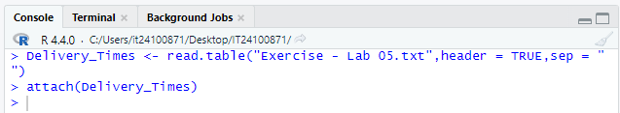

2.

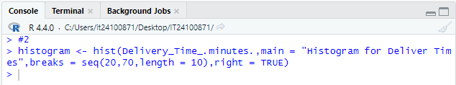

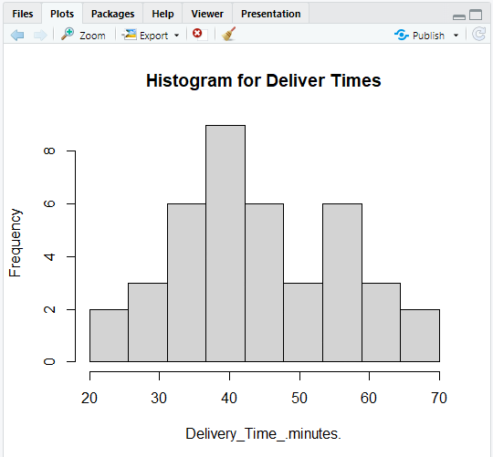

3.

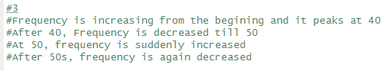

4.

